|  |
| --- |
|  |
| VIRTUAL DOCTOR |
| PROJECT REPORT |

|  |
| --- |
| Programmed and Presented by:  DHRITI BHASIN(CO19321)  KRITI AGGRAWAL(CO19335)  MUSKAAN CHOPRA(CO19342) |
|  |



ACKNOWLEDGEMENT

The credit for the successful completion of this project work goes beyond our own work, to those people who have always been with us throughout. And we take this opportunity to express our heartfelt gratitude to each one of them.

We express our sincere thanks to our Mentor **Dr. Sarabjeet Singh** of for his valuable suggestions and providing guidance throughout the project, that enabled us to complete this project successfully.

ABSTRACT

The main aim of our project is to provide an instant and portable method of disease diagnosis and booking appointments.

This project is intended to generate a meaningful set of details about the diseases, evaluation of symptoms and emergency services.

Table of Contents

1. INTRODUCTION

2. SYSTEM ANALYSIS

2.1 EXISTING SYSTEM

2.2 PROPOSED SYSTEM

2.2.1 SCOPE OF THE PROJECT

3. AIM OF THE PROJECT

4. PROJECT MODULES

5. COMPILER SPECIFICATIONS

6. SYSTEM DESIGN

6.1 FLOW CHARTS

7. SYSTEM IMPLEMENTATION

7.1 MODULAR DESCRIPTION

8. RESULT

9. CONCLUSION

10. REFERENCES

# INTRODUCTION

The" VIRTUAL DOCTOR" is a substitute to the local primary healthcare system. It acts as a charity at the intersection of technology and medicine. As it is hard for people who stay in remote areas to travel long distances and heavy travel expenditure, this application provides a faster way to detect health problems. It provides better healthcare at your fingertips. This acts as a medical consultant at your doorstep. The software developed at the end of this project detects the disease affected to the user based on the symptoms given as the input by the patient..

It is hard to get to know about the diseases one has by manual judgment, so we have included both methods of search i.e. one can give disease as a input and get to know its symptoms and medicines or can input the symptoms and get to know the disease and is available any time needed. This application is an economy one as it save people’s money and time too. Lot of expenditure is cut off, like doctor’s consultation fee, travelling expenses etc.

# SYSTEM ANALYSIS

## 2.1 EXISTING SYSTEM

Currently there are only limited facilities available such as meeting the doctor personally where the time consumed will be more and in the present days e-consultation is also available to help the patients.

## 2.2 PROPOSED SYSTEM

### 2.2.1 SCOPE OF THE PROJECT

The main function of this software system is as follows:

* The patients are able to detect the diseases by themselves.
* Provides consultancy service round the clock.
* The software can be updated to include new symptoms and diseases.

# AIM OF THE PROJECT

[1]This project is aimed to provide a tool for easy consultation at the finger tips in an efficient and an easy manner. The purpose of the project entitled as “VIRTUAL DOCTOR” is to computerize all the activities by developing the required software which will help people to analyze the diseases, their

The main aim of the project in hand is to provide an improved, faster and instant approach of diagnosing .The patient himself able to know the causes of his disease .

# PROJECT MODULES

The project has been slashed into many small modules to run effectively, easy to understand and debug. Some important modules used in the project are:

* Home module(menu).
* Conditions and Symptoms evaluation module.

# COMPILER SPECIFICATION

The software is been designed using dev c++ in windows operating system. It has to be used on the specific system.

This program uses features like nullptr and stoi function. The -std=c++11 command is added to compiler for the same .

# 

# 6. SYSTEM DESIGN

## 6.1 FLOW CHARTS

MENU

QUEUE ORDER

DOCTOR INTERFACE

PATIENT INTERFACE

Exit

# 

# 7. SYSTEM IMPLEMENTATION

The program is been designed by making use of different modules and these modules help each other in the effective working of the program to give a specified result.

## 

## 7.1 MODULAR DESCRIPTION

**The project has been slashed into many small modules to run effectively, easy to understand and debug. Some important modules used in the project are:**

* **Home module(menu).**
* **Conditions and Symptoms evaluation module.**

**Home Module:** **This module gives the information about the different tabs that are being used In the program.**

* **The user can make use of this home module to know about the tabs which he or she has to make use.**
* **In the program we have made use of tabs like patient interface, doctor interface and patients in queue.**
* **This module gives a overview of all other tabs.**

**Conditions and Symptoms evaluation Module:** **To have glance about the known disease or infection.**

* **The user has to select symptoms from given options and software gives the possible disease for that symptom(s).**
* **If symptoms does not match then type 0 to open a window to describe your conditions and allow doctors to diagnose the conditions.**

.

# 8. RESULTS

1)MENU

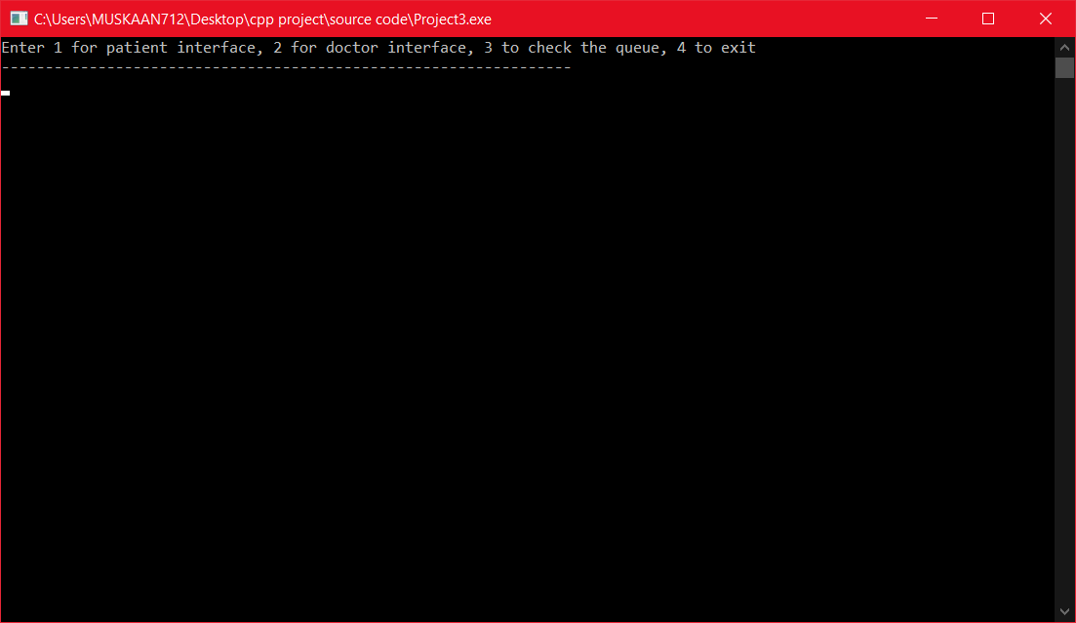

2)PATIENT INTERFACE(1)

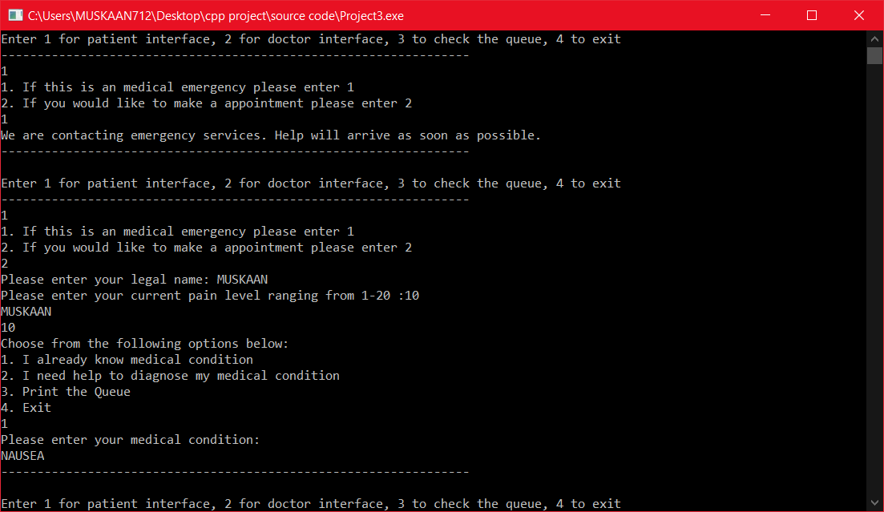

3)PATIENT INTERFACE(2)

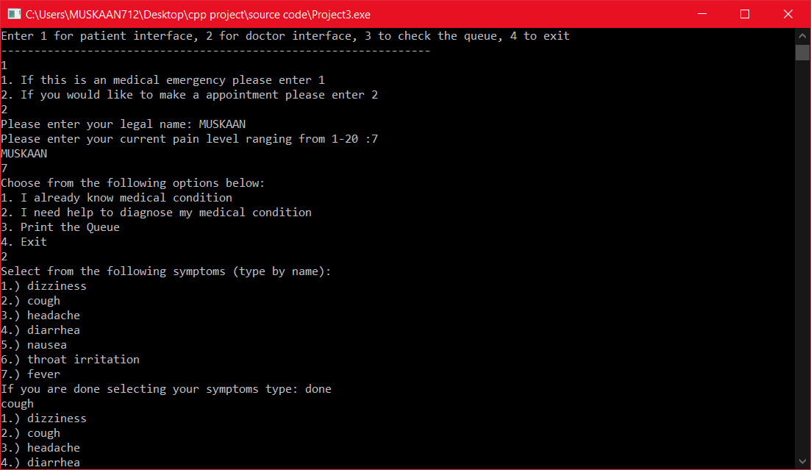

4)PATIENT INTERFACE(3)

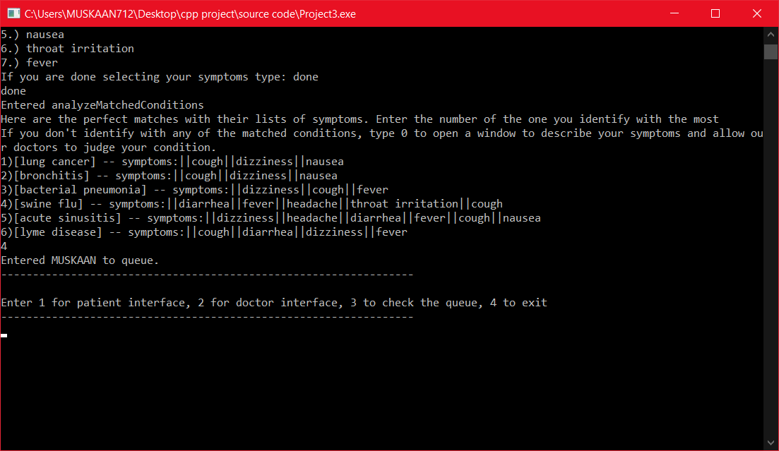

5)PATIENT INTERFACE(4)

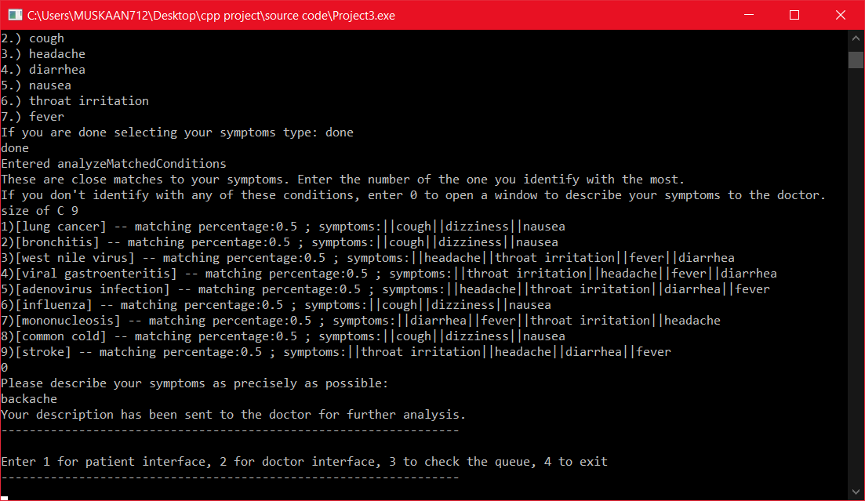

5)DOCTOR INTERFACE

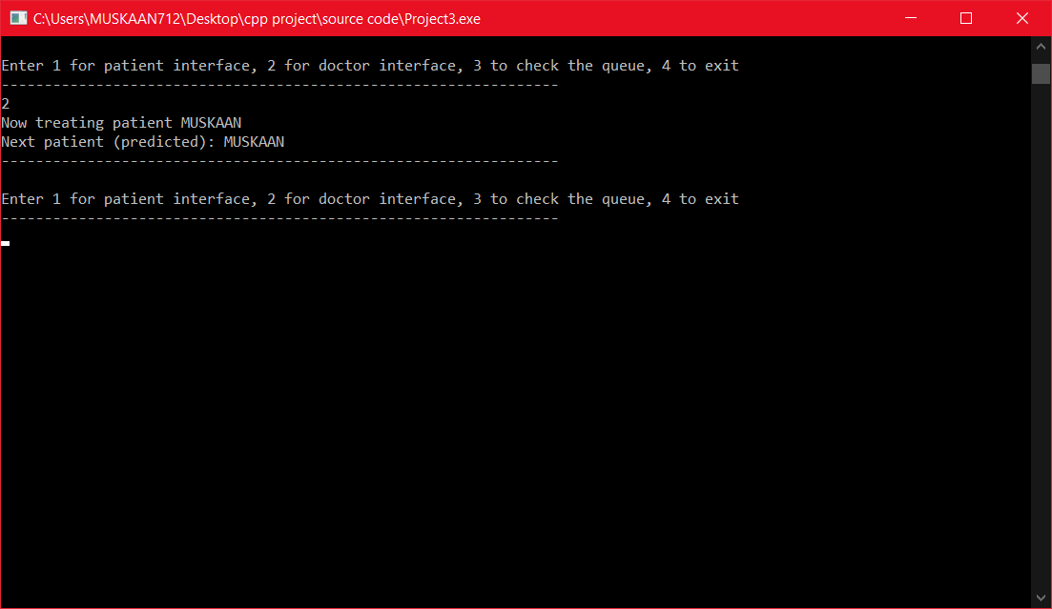

# 9. CONCLUSION

The result obtained is a complete package of program which is able to detect disease and fix appointments.

# 10. REFERENCES

* [www.google.com](http://www.google.com/)
* Big c++  by Cay S. Horstmann.
* Object Oriented Programming in C++ by E.Balagurusamy.
* github.com